Tree Plantation Day was celebrated with great enthusiasm through a joint effort by NCC students and the Rotary Club. Together, they planted saplings in the surrounding area to promote environmental awareness. The event emphasized the importance of trees in fighting climate change and preserving nature. Speeches and posters added to the message of green responsibility. This collaborative initiative ended with a pledge to care for the environment and plant more trees in the future.

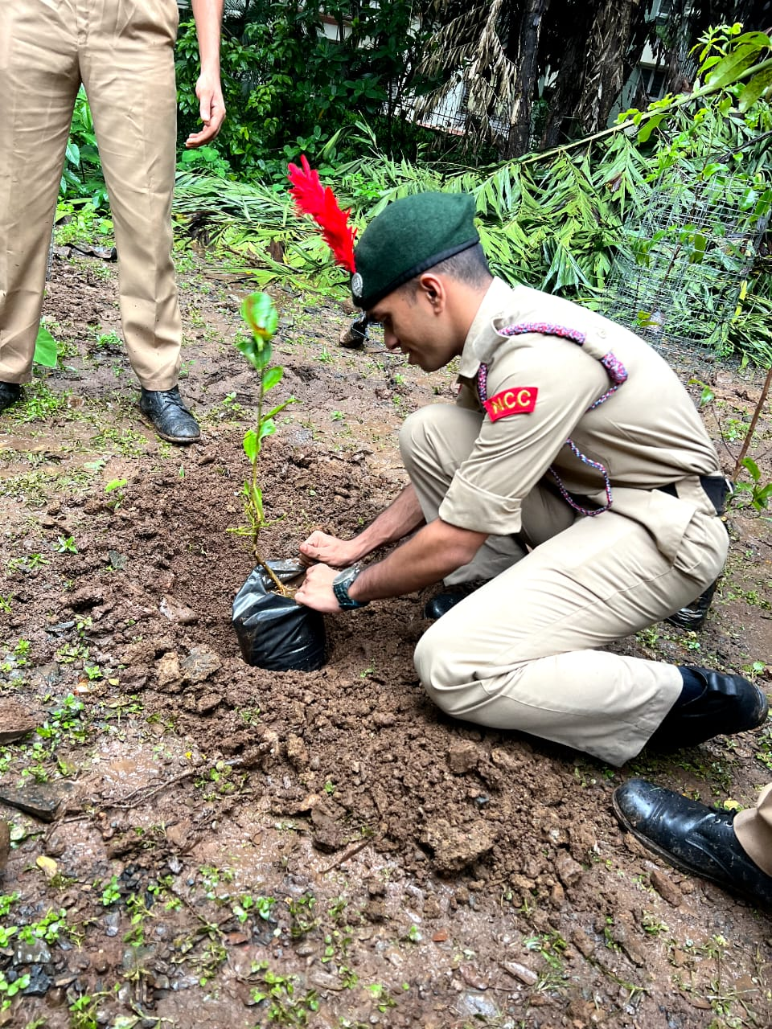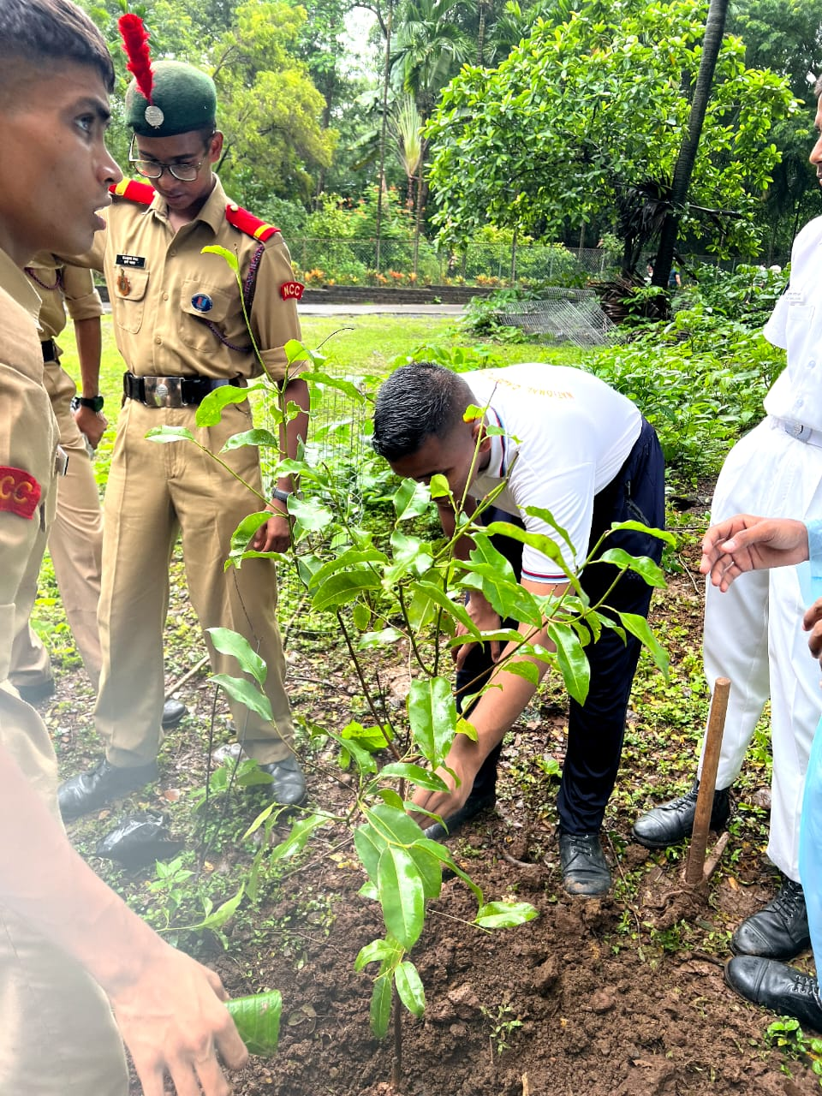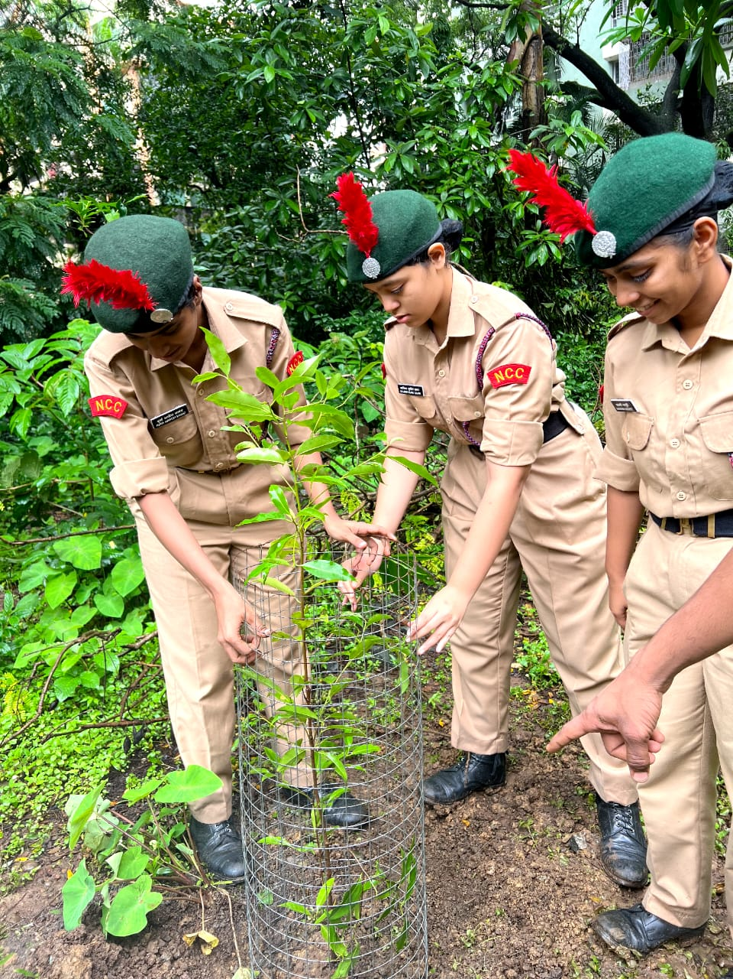

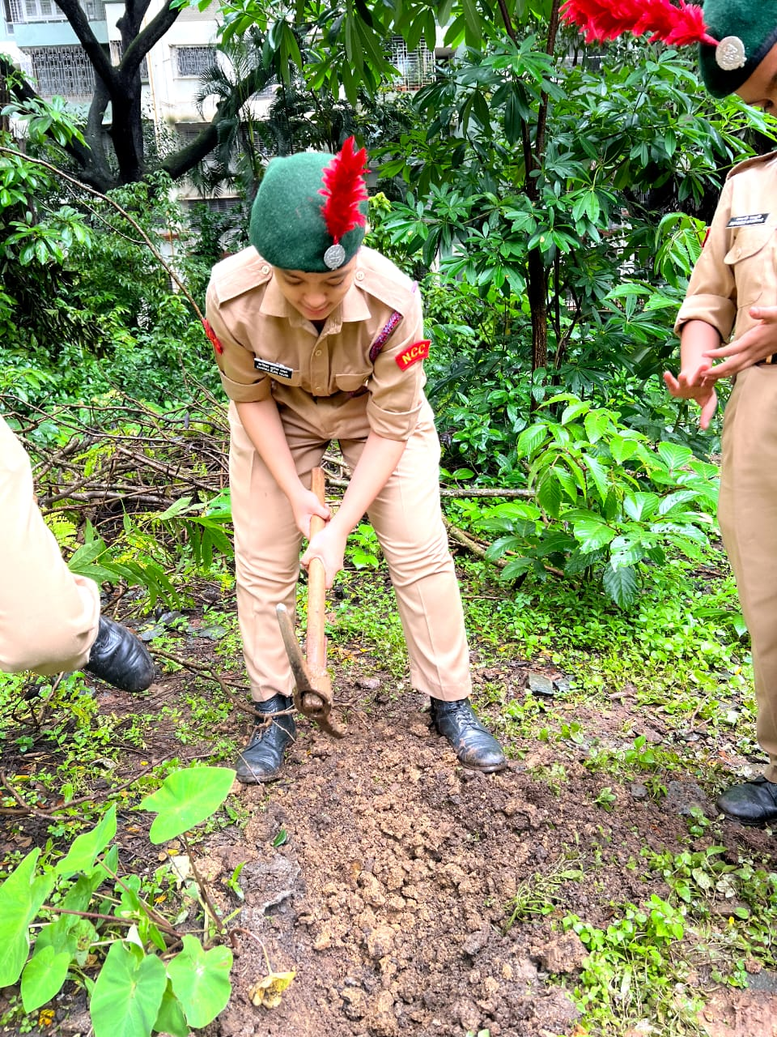 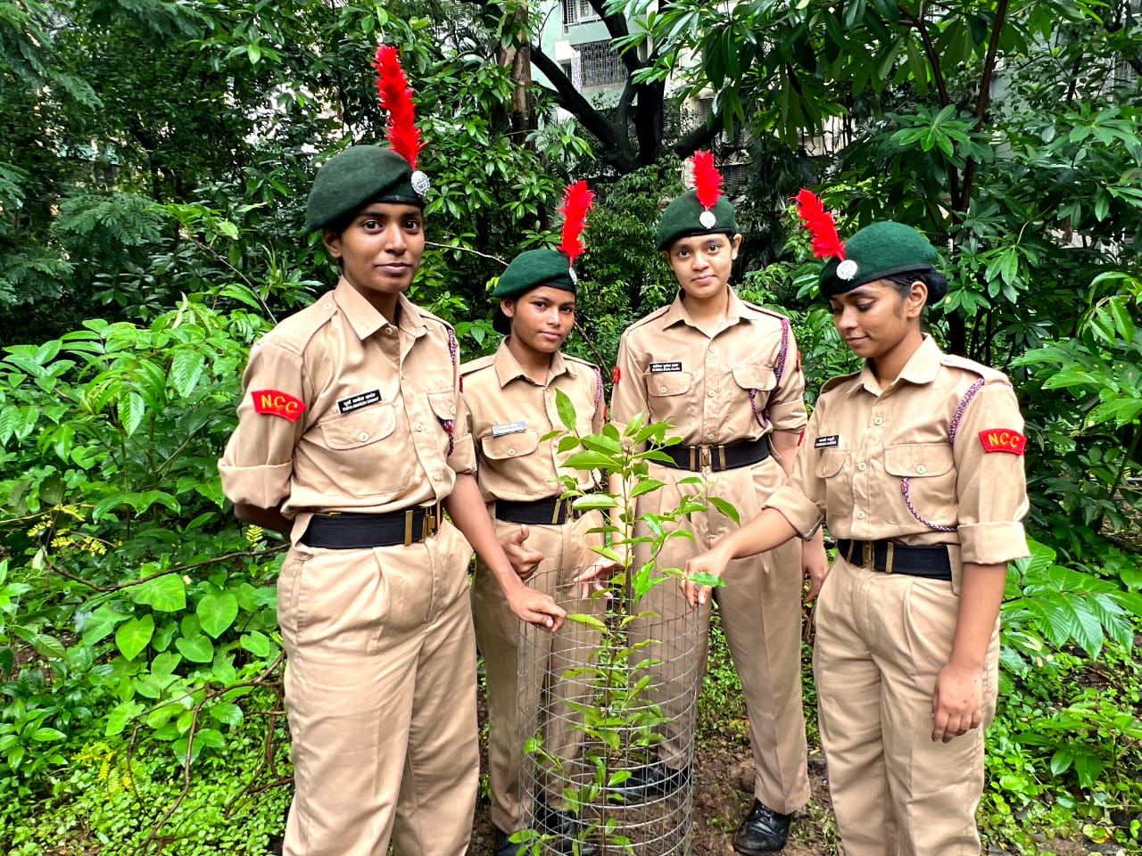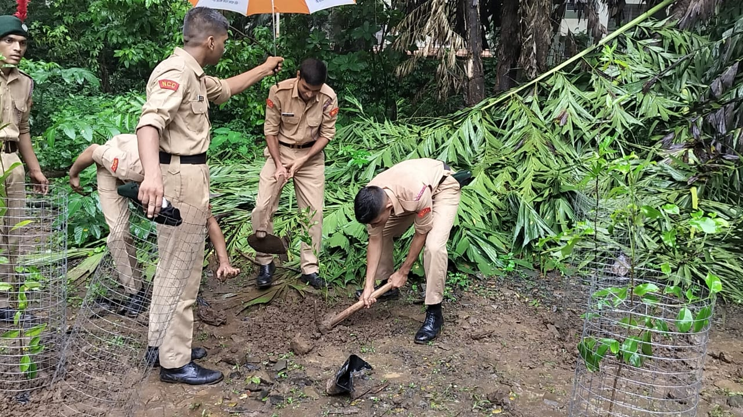 m 